Şaka Devresi

NOT: Samm marketten aldığımdan dolayı ESP8622 yi güncelledim ama durmadan hata aldım onun için videoları atamadım. ESP8622 mde sorun vardı sanırım yenide alamadım. Kabul ederseniz mutlu edersiniz. İyi çalışmalar 😊

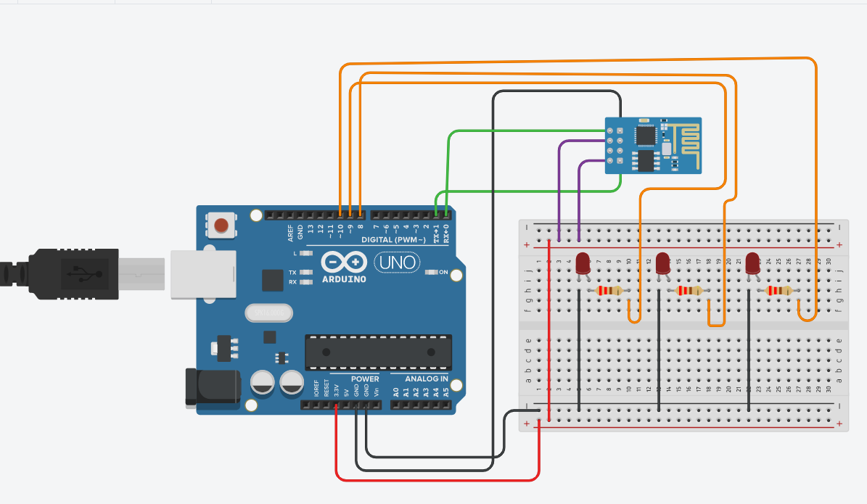

/*************************************************************

Download latest Blynk library here:

https://github.com/blynkkk/blynk-library/releases/latest

Blynk is a platform with iOS and Android apps to control

Arduino, Raspberry Pi and the likes over the Internet.

You can easily build graphic interfaces for all your

projects by simply dragging and dropping widgets.

Downloads, docs, tutorials: http://www.blynk.cc

Sketch generator: http://examples.blynk.cc

Blynk community: http://community.blynk.cc

Follow us: http://www.fb.com/blynkapp

http://twitter.com/blynk_app

Blynk library is licensed under MIT license

This example code is in public domain.

*************************************************************

This example shows how value can be pushed from Arduino to

the Blynk App.

NOTE:

BlynkTimer provides SimpleTimer functionality:

http://playground.arduino.cc/Code/SimpleTimer

App project setup:

Value Display widget attached to Virtual Pin V5

*************************************************************/

/* Comment this out to disable prints and save space */

#define BLYNK_PRINT Serial

#include<Ardunıo.h>

#include <ESP8266WiFi.h>

#include <BlynkSimpleEsp8266.h>

#define led D2

#define led D3

#define led D4

int butondurumu=0;

// You should get Auth Token in the Blynk App.

// Go to the Project Settings (nut icon).

char auth[] = "M8IjKO0ubeY11Kuwripd7ZC96oA0vp_W";

// Your WiFi credentials.

// Set password to "" for open networks.

char ssid[] = "*************";

char pass[] = "******";

BlynkTimer timer;

BLYNK_WRITE(V1)

{

int pinValue=param.asInt();

if (pinValue==1){

Serial.println("AÇIK");

digitalWrite(led,HIGH);

delay(5000);

butondurumu=1;

}

else{

Serial.println("KAPALI");

digitalWrite(led,LOW);

butondurumu=0;

}

}

BLYNK_WRITE(V2)

{

int pinValue=param.asInt();

if (pinValue==1){

Serial.println("AÇIK");

digitalWrite(led,HIGH);

delay(5000);

digitalWrite(led,LOW);

butondurumu=1;

}

else{

Serial.println("KAPALI");

digitalWrite(led,LOW);

butondurumu=0;

}

}

BLYNK_WRITE(V3)

{

int pinValue=param.asInt();

if (pinValue==1){

Serial.println("AÇIK");

digitalWrite(led,HIGH);

delay(5000);

digitalWrite(led,LOW);

butondurumu=1;

}

else{

Serial.println("KAPALI");

digitalWrite(led,LOW);

butondurumu=0;

}

}

void veriGonder()

{

String h;

if(butondurumu==1)(h="LED ACIK";)

else(h="LED KAPALI";)

Blynk.virtualWrite(V2,h);

}

// This function sends Arduino's up time every second to Virtual Pin (5).

// In the app, Widget's reading frequency should be set to PUSH. This means

// that you define how often to send data to Blynk App.

void myTimerEvent()

{

// You can send any value at any time.

// Please don't send more that 10 values per second.

Blynk.virtualWrite(V5, millis() / 1000);

}

void setup()

{

// Debug console

Serial.begin(115200);

pinMode(D2,OUTPUT);

pinMode(D3,OUTPUT);

pinMode(D4,OUTPUT);

Blynk.begin(auth, ssid, pass);

// You can also specify server:

//Blynk.begin(auth, ssid, pass, "blynk-cloud.com", 80);

//Blynk.begin(auth, ssid, pass, IPAddress(192,168,1,100), 8080);

// Setup a function to be called every second

timer.setInterval(1000L, veriGonder);

}

void loop()

{

Blynk.run();

timer.run(); // Initiates BlynkTimer

}